**SQL Assignment**

Q-1 write a SQL query to find customers who are either from the city 'NewYork' or who do not have a grade greater than 100. Return customer_id, cust_name, city, grade, and salesman_id.

Input:-

select customer_id,cust_name,city,grade,salesman_id

from customer

where city ='New York' or grade<100;

Output:-

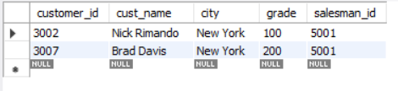

Q-2 write a SQL query to find all the customers in ‘New York’ city who have agradevalue above 100. Return customer_id, cust_name, city, grade, and salesman_id.

Input:-

select customer_id,cust_name,city,grade,salesman_id

from customer

where city ='New York' and grade>100;

Output:-

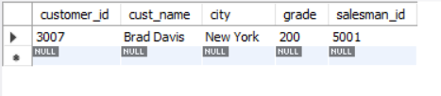

Q-3 Write a SQL query that displays order number, purchase amount, and the achieved and unachieved percentage (%) for those orders that exceed 50%of the target value of 6000.

Input:-

select ord_no,purch_amt,round((purch_amt / 6000)* 100,2) as achieved,round(100 - (purch_amt / 6000)* 100,2) as unachieved

from orders

where purch_amt > 3000;

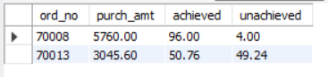Output:-

Q-4 write a SQL query to calculate the total purchase amount of all orders. Returntotal purchase amount.

Input:-

select sum(purch_amt) as total_purchase_amount

from orders;

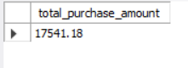Output:-

Q-5 write a SQL query to find the highest purchase amount ordered by each customer. Return customer ID, maximum purchase amount.

Input:-

select customer_id, max(purch_amt) as max_purchase

from orders

group by customer_id;

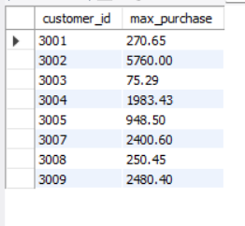Output:-

Q-6 write a SQL query to calculate the average product price. Return average product price.

Input:-

select * from item_mast;

select round(avg(pro_price),2) as average_product_price

from item_mast;

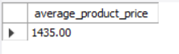Output:-

Q-7 write a SQL query to find those employees whose department is located at ‘Toronto’. Return first name, last name, employee ID, job ID.

Input:-

select first_name,last_name,employee_id,job_id

from emp_details_view

where city = 'Toronto';

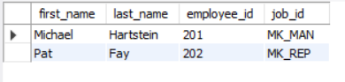Output:-

Q-8 write a SQL query to find those employees whose salary is lower than that of employees whose job title is "MK_MAN". Exclude employees of the Jobtitle‘MK_MAN’. Return employee ID, first name, last name, job ID.

Input:-

with min_salary as (

select salary

from emp_details_view

where job_id='MK_MAN'

)

select employee_id, first_name, last_name, job_id

from emp_details_view

where salary<(select salary from min_salary)and job_id<>'MK_MAN';

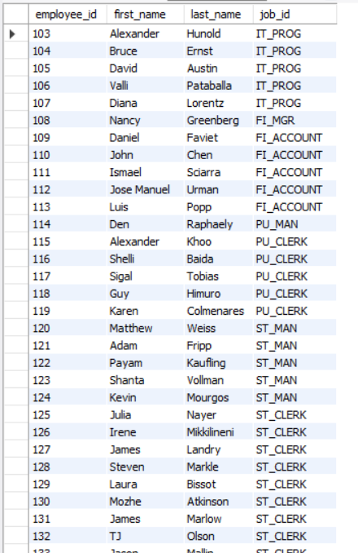Output:-

Q-9 write a SQL query to find all those employees who work in department ID80or40. Return first name, last name, department number and department name.

Input:-

select first_name, last_name, department_id,department_name

from emp_details_view

where department_id = 80 or department_id = 40;

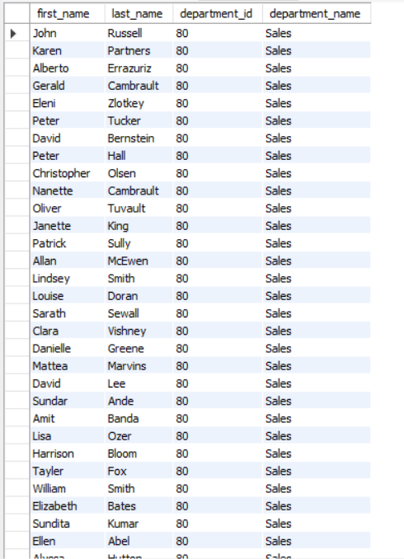Output:-

Q-10 write a SQL query to calculate the average salary, the number of employees receiving commissions in that department. Return department name, averagesalary and number of employees.

Input:-

Select department_name,round(avg(salary),2)as average_salary,count(commission_pct) as employees

from emp_details_view

group by department_name;

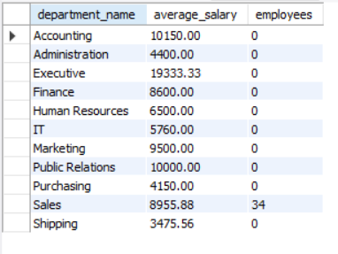Output:-

Q-11 write a SQL query to find out which employees have the same designationas theemployee whose ID is 169. Return first name, last name, department IDandjobID.

Input:-

with emp as (

select job_id

from emp_details_view

where employee_id=169)

select first_name, last_name, department_id,job_id

from emp_details_view

where job_id = (select job_id from emp);

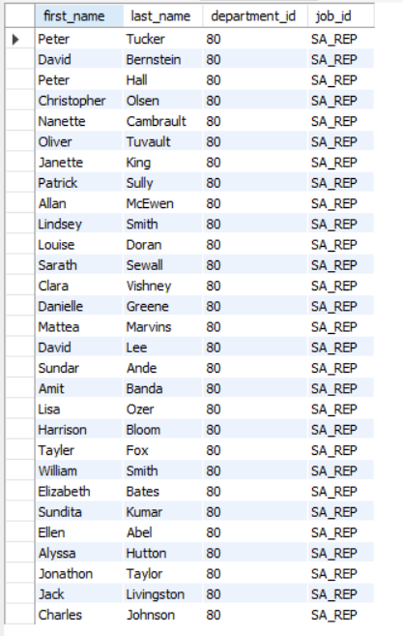Output:-

Q-12 write a SQL query to find those employees who earn more than the averagesalary. Return employee ID, first name, last name.

Input:-

with avgs as (

select avg(salary) as avrage

from emp_details_view

)

select employee_ID, first_name, last_name

from emp_details_view

where salary >(select avrage from avgs);

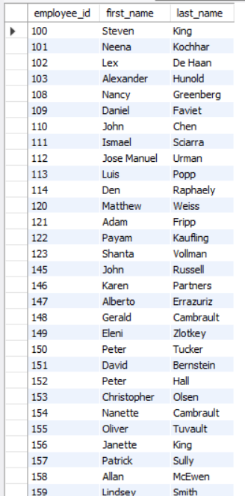Output:-

Q-13 write a SQL query to find all those employees who work in the Finance department. Return department ID, name (first), job ID and department name.

Input:-

select department_id,first_name, job_id,department_name

from emp_details_view

where department_name = 'Finance';

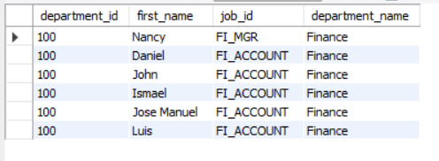Output:-

Q-14 From the following table, write a SQL query to find the employees who earn lessthan the employee of ID 182. Return first name, last name and salary.

Input:-

with employe as (

select salary

from emp_details_view

where employee_id =182

)

select first_name, last_name,salary

from emp_details_view

where salary<(select salary from employe);

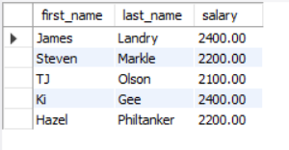Output:-

Q-15 Create a stored procedure CountEmployees By Dept that returns the number of employees in each department.

Input:-

delimiter //

create procedure emp_details()

begin

select department_name,count(*) as employees

from emp_details_view

group by department_name;

end;

//

call emp_details();

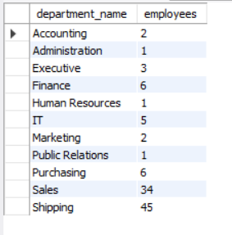Output:-

Q-16 Create a stored procedure AddNewEmployee that adds a new employee tothedatabase.

Input:-

delimiter //

create procedure add_employee(

in emp_id INT (11) UNSIGNED,

in fname VARCHAR(20),

in lname VARCHAR(25),

in em VARCHAR(25),

in pnumber VARCHAR(20),

in hdate DATE,

in jid VARCHAR(10),

in sal DECIMAL(8, 2),

in comm DECIMAL(2, 2),

in mid INT (11) UNSIGNED,

in did INT (11) UNSIGNED

)

begin

insert into employees(employee_id,first_name,last_name,email,phone_number,hire_date,job_id,salary,commission_pct,manager_id,department_id)

values(emp_id,fname,lname,em,pnumber,hdate,jid,sal,comm,mid,did);

end;

//

delimiter;

call add_employee(207,'bob','smith','JUSTIN','515.169.9999','1995-05-06','AC_MGR',20000.00,null,207,111);

select * from employees;

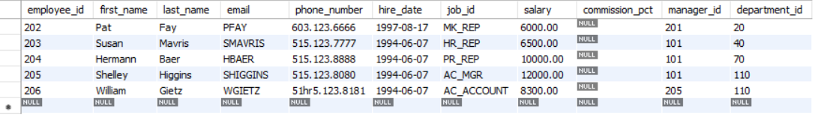Output:-

Before

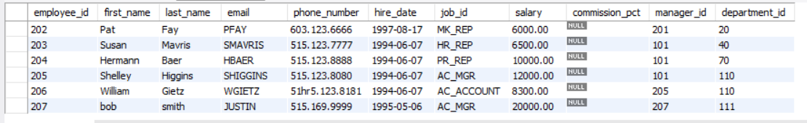

After

Q-17 Create a stored procedure DeleteEmployeesByDept that removes all employeesfrom a specific department

Input:-

SET SQL_SAFE_UPDATES = 0;

delimiter //

create procedure delete_emp(

in deptid int

)

begin

delete from employees

where department_id = deptid;

end;

//

delimiter;

call delete_emp(30);

select * from employees;

Output:-

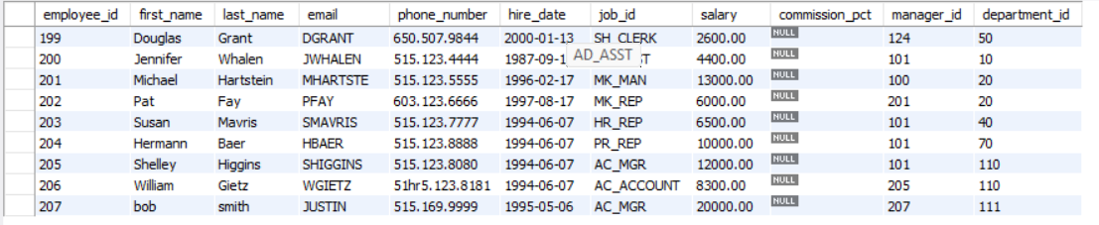

Q-18 Create a stored procedure GetTopPaidEmployees that retrieves the highest-paidemployee in each department.

Input:-

delimiter //

create procedure high_paid_emp()

begin

with emp as (

select first_name,last_name,salary,department_name,

rank() over(partition by department_name order by salary desc) as ranks

from emp_details_view)

select *

from emp

where ranks=1;

end//

delimiter;

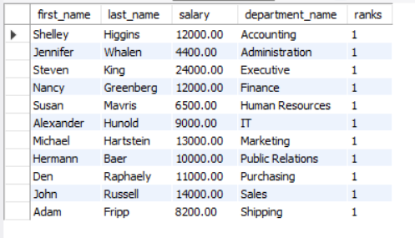Output:-

Q-19 Create a stored procedure PromoteEmployee that increases an employee’s salaryand changes their job role.

Input:-

delimiter //

create procedure promoteemployee (

in empid int,

in newjobid varchar(10),

in newsalary decimal(10,2)

)

begin

-- update salary and job id

update employees

set

salary = newsalary,

job_id = newjobid

where

employee_id = empid;

end;

//

delimiter ;

select * from employees;

call promoteemployee(125,'ST_MAN',5000.00);

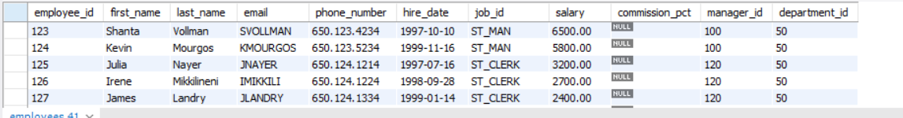Output:-

Before

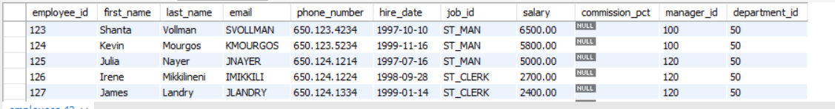

After

Q-20 Create a stored procedure AssignManagerToDepartment that assigns a newmanager to all employees in a specific department.

Input:-

select * from departments;

delimiter //

create procedure assign (

in mid int,

in deptid int

)

begin

update departments

set manager_id = mid

where department_id = deptid;

end;

//

delimiter ;

call assign(202,20);

select * from departments;

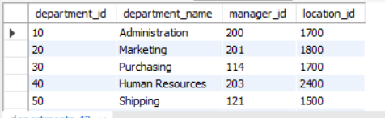Output:-

Before

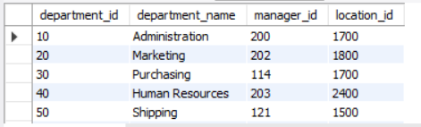

After